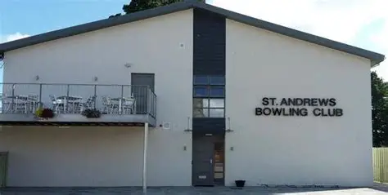
ST ANDREWS BOWLING CLUB TEL: 01334 472301
1 PIPELAND ROAD MOB: 07359222760
ST ANDREWS
KY16 8JN
FUNCTION HALL HIRE
Applicants Full Name ___________________________________________________________
Full Address ____________________________________________________________
Post Code _______________________ Contact Phone No: ____________________________
Email Address ____________________________________________________________
Type of Function ____________________________________________________________
Date of Function ______________________ Time needed __________________________________
Nos Attending(max 100) ____________________________________________________________
No of Tables: Round(seats 10) __________________ Long(seats 8) _________________
Type of Entertainment(eg Disco/Band) ______________________________________________
Will the Kitchen be required YES / NO
Any decorations must be pinned to the wall – no blue tack or cellotape
Any Special drinks or other requirements
_________________________________________________________________________________________
I agree to
*Deposit must be paid within 7 days of booking. This is refundable following the event within 7 days, if the Function Hall is left CLEAN and TIDY and NO DAMAGE INCURRED. *Pay the full amount 7 days prior to the Event.

*Pay the full amount 7 days prior to the Event.
Signature of Applicant ___________________________________________________________________
Date ______________________
Office Use only
Agreed by Committee date ____________________________________________________________
Deposit paid date ____________________________________________________________

Deposit Member £50. Hourly Rate £30 per hour
Deposit Non Member £100. Hourly Rate £35 per hour
Please return to Willie Donaldson – Email address bowlingclubhallbookings@gmail.com

